We use Remix IDE to compile our solidity, testrpc to simulate ethereum network. In the front-end app, we use javascript and web3 to interact with our contract. We want to create a smart contract that act as an intermediate between buyer and seller and make sure that neither side can control the contract after it has been deployed. Here is a normal flow:

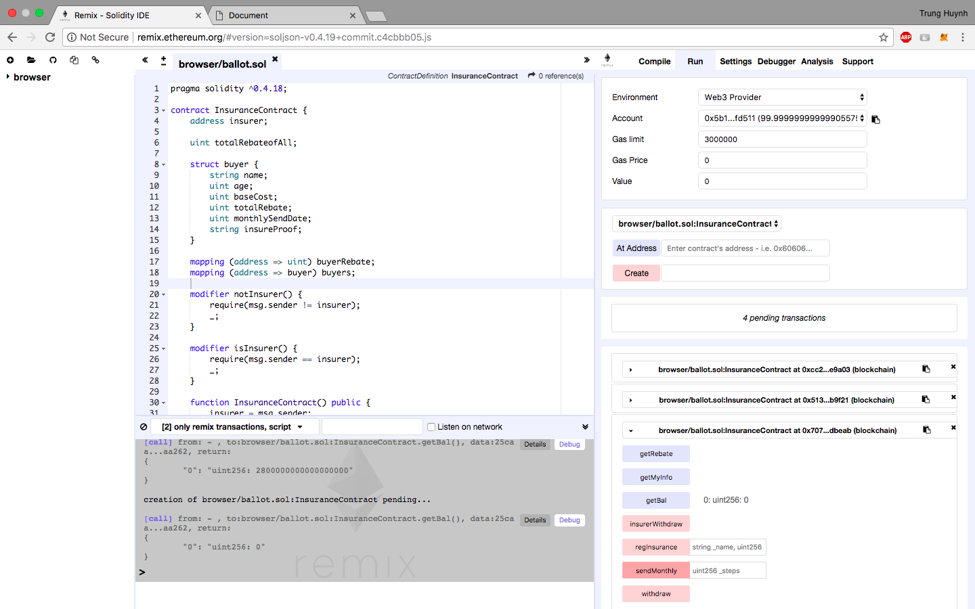

Web3 is injected to our front-end app using Metamask. Account 4 was chosen to create the contract and is the owner of the contract.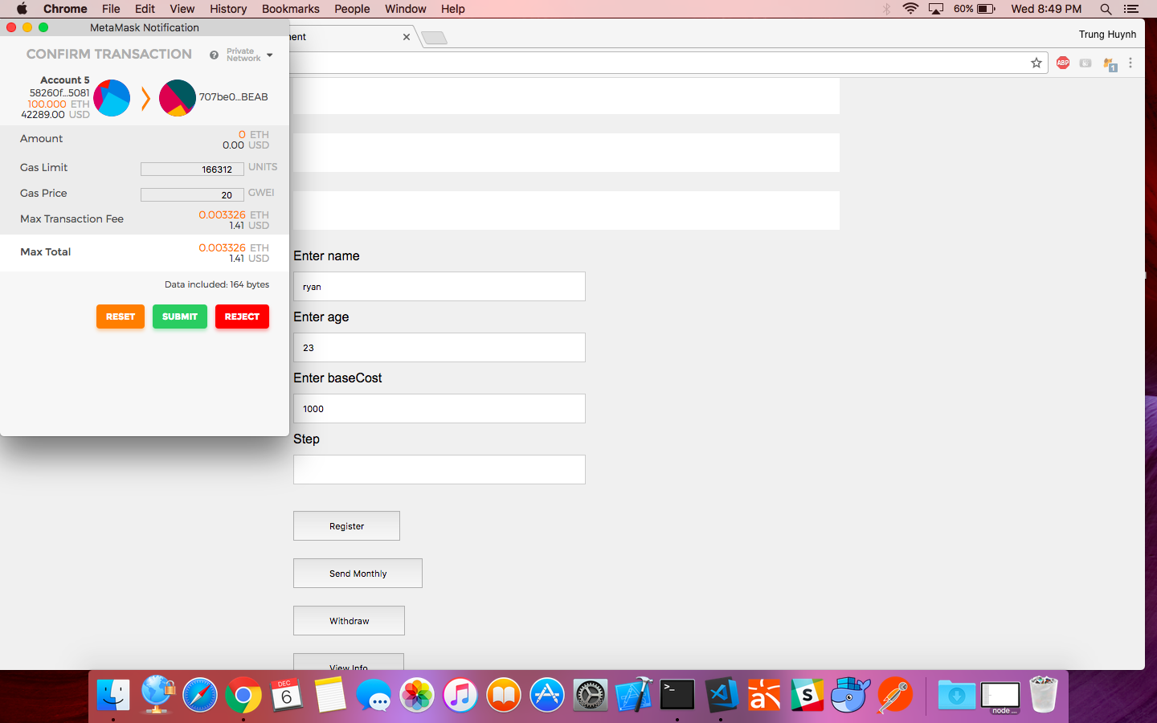

Now we change to account 5, this account is our regular user who will be able to register to the contract by giving Name, Age, and BaseCost and click register.

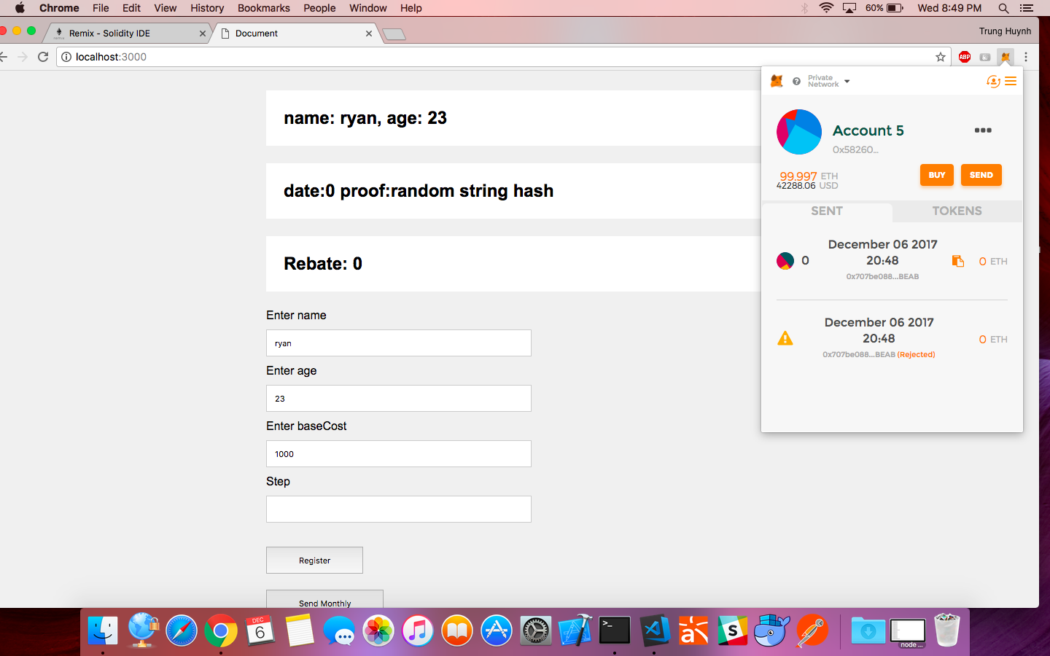

After register, Account 5 balance go down a bit (it is the fee for miner to execute the message call) and you can see the newly created information.

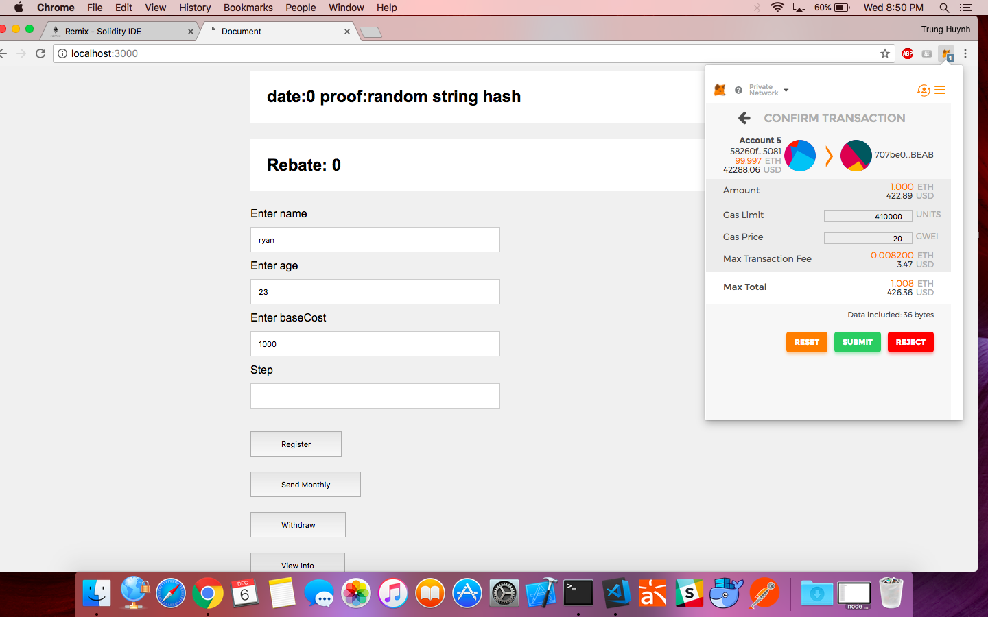

Account 5 can now click the Send Money button to send payment and number of steps he walks in this month to the contract owner. In here we send 1 Ether and 0 step.

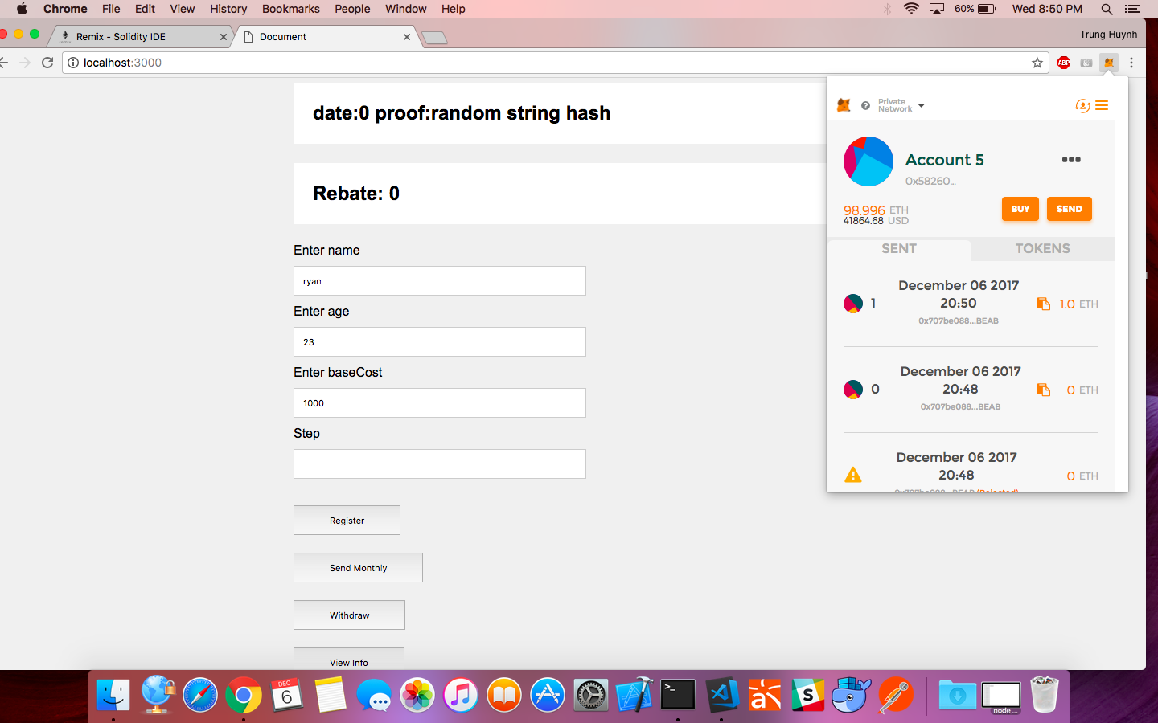

After we sent the money, Account 5 balance is now 1 Ether less and since our step was 0, the rebate value is 0.

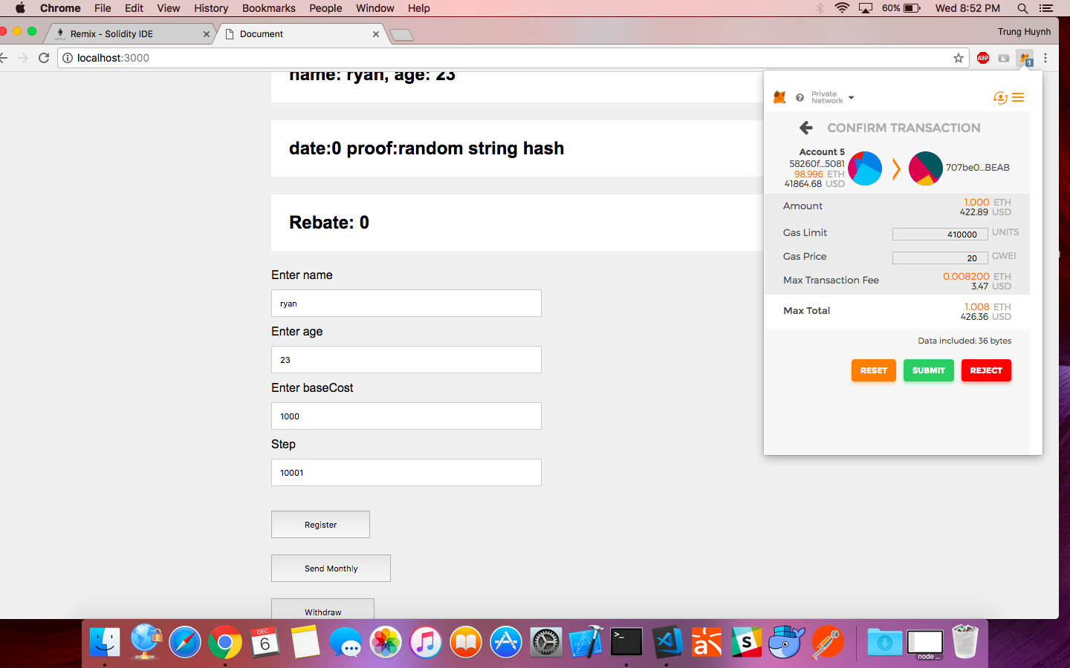

We do this again this time sending 1 Ether with 10001 steps.

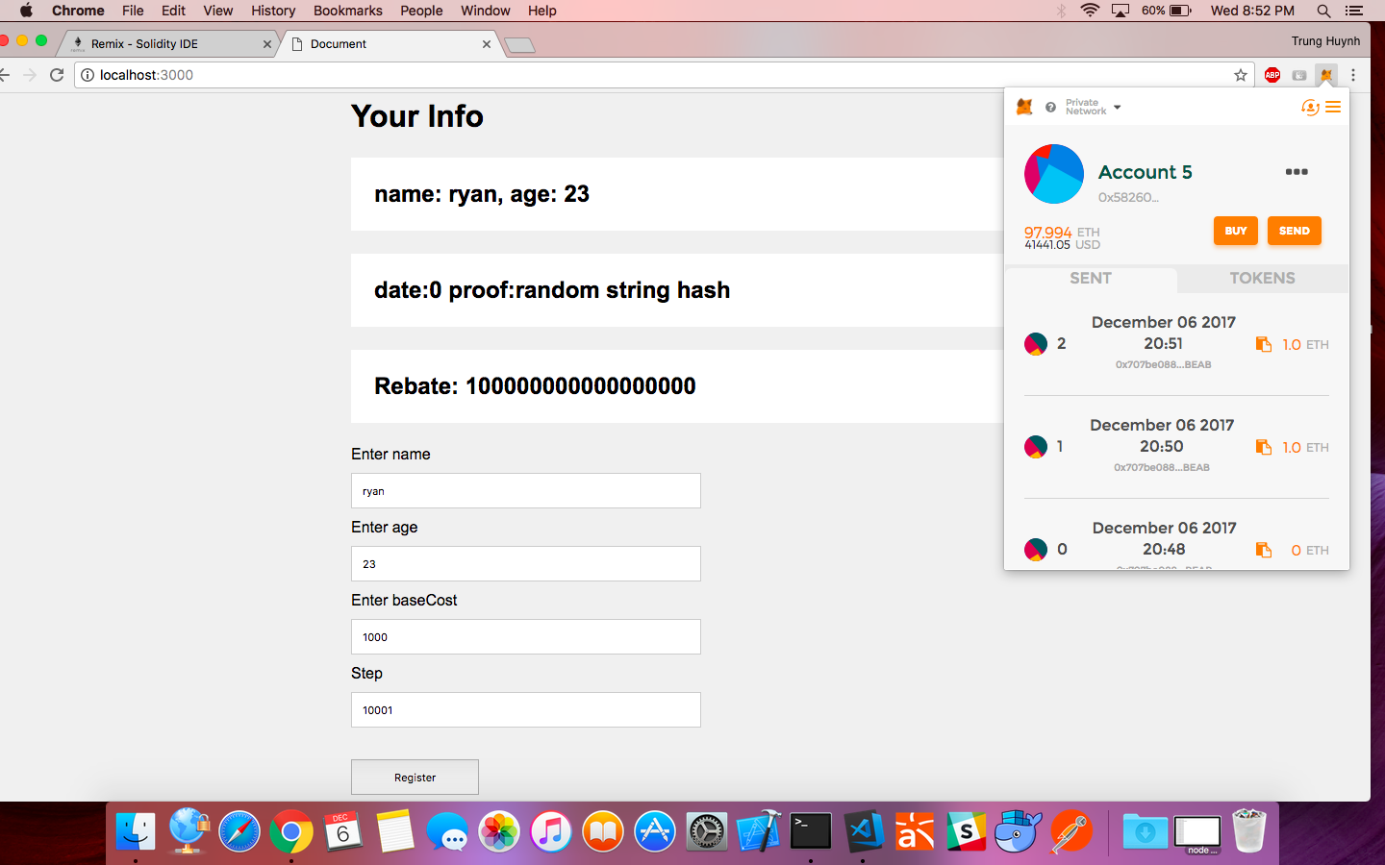

After it completed, the rebate value increase to 0.1 Ether. This is the rebate that this user earned by walking 10001 this month. Notice that the rebate is still stored in the contract along with all the other transaction up to now.

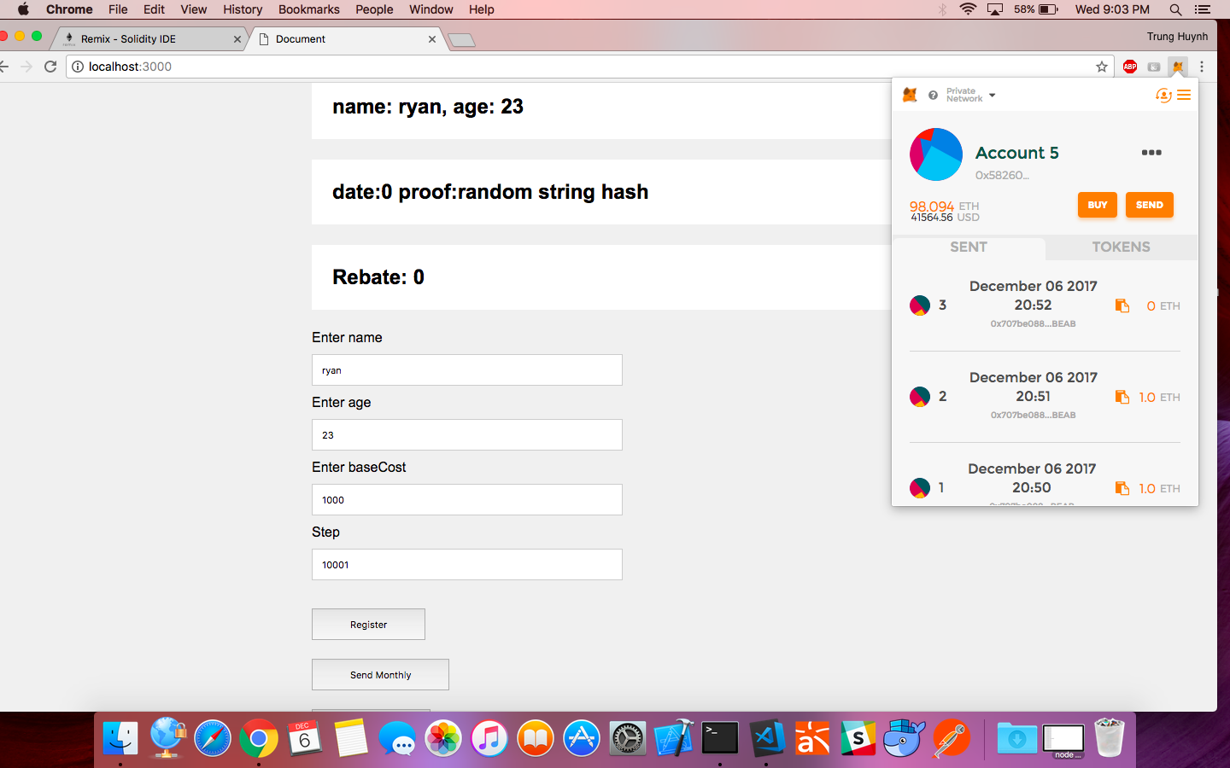

When this user click on withdraw, the rebate value is transferred to account 5 and the balance increase accordingly.

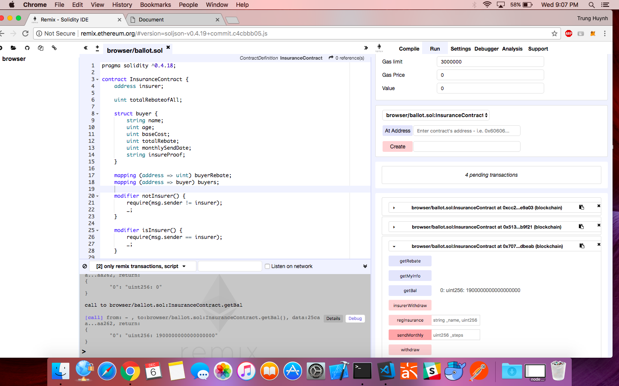

If you look at the getBal function in the bottom right, you will see the available balance of the contract up to now which is 1.9 ETH (because we sent 2 times but only one has rebate for walking more than 10000).

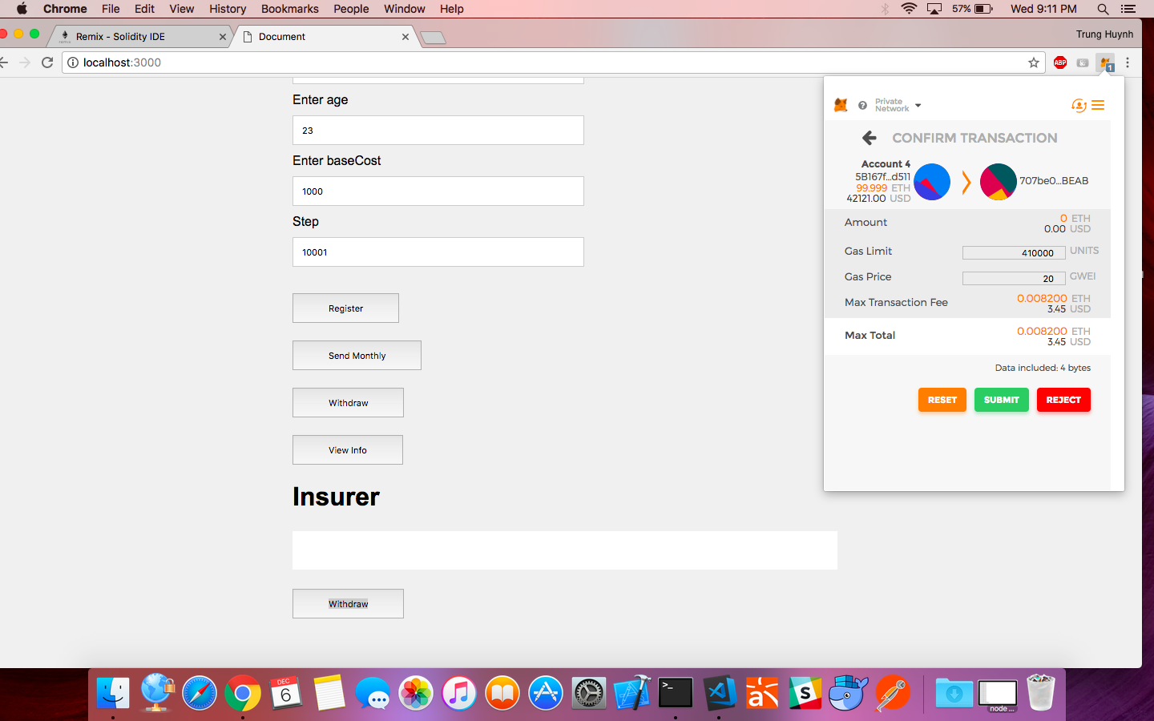

Now we switch back to account 4 (the owner) we can click on the withdraw button in the Insurer region.

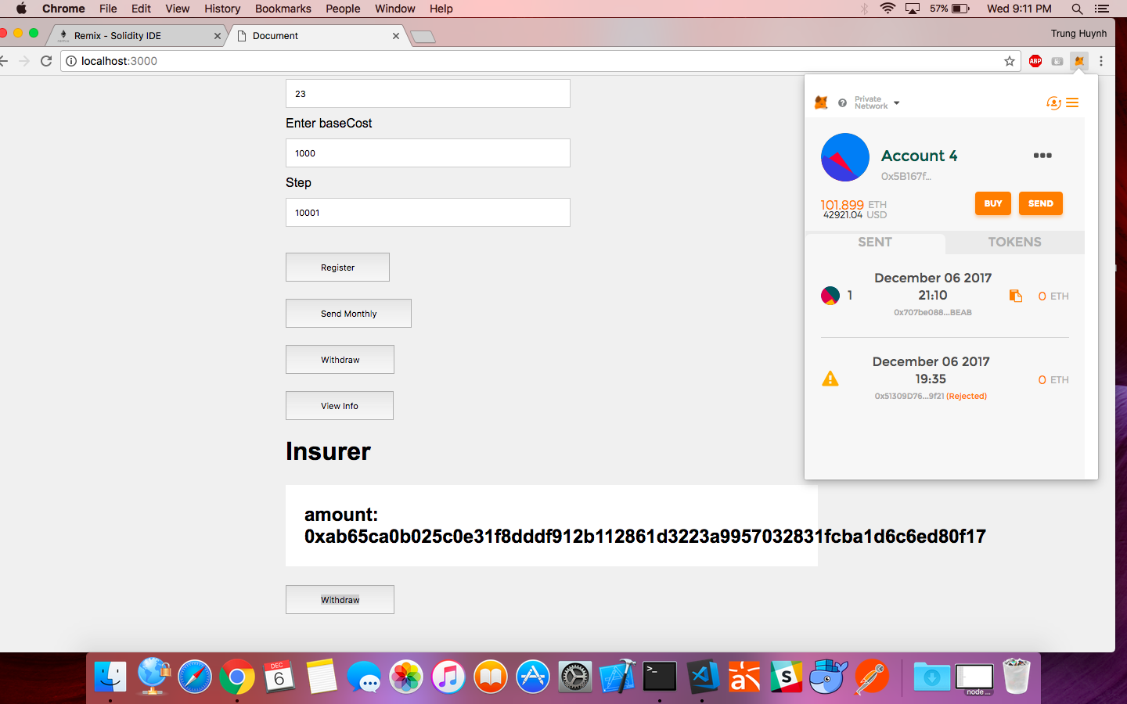

The balance increase after the transaction block is mined and the account 4’s balance increase by 1.9 Ether.

Note that the owner can withdraw anytime but only a specific amount can be withdraw from the Contract, the amount that is left is the total rebate of all the users. This make sure that the user can still withdraw their rebate after the insurer withdraw.

Also note, the owner can only call the insurerWithdraw message, and the user can only call register, sendMonthly, withdraw and viewInfo.